Correction
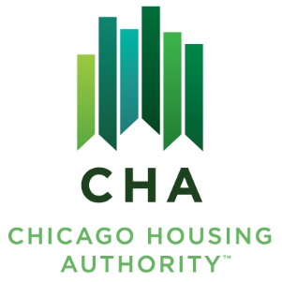

NOTICE OF THE REGULAR MEETINGS
OF
THE BOARD OF COMMISSIONERS

YOU ARE HEREBY NOTIFIED that the Regular meetings of the Board of Commissioners of the Chicago Housing Authority for the month of November 2014 are scheduled as follows:

COMMITTEE MEETINGS
CHA Corporate Offices, 60 East Van Buren, 12th Floor Loft, Chicago, Illinois
Wednesday, November 12, 2014 1:00 p.m. Tenant Services Committee
Wednesday, November 12, 2014 1:15 p.m. Operations & Facilities Committee
Wednesday, November 12, 2014 1:30 p.m. Real Estate Development Committee
Wednesday, November 12, 2014 1:45 p.m. Finance & Personnel Committee

BOARD MEETING
Charles Hayes Family Investment Center, 4859 South Wabash, Chicago, Illinois
Tuesday, November 18, 2014 8:30 a.m. – Closed Meeting 9:30 a.m. – Business Session and Public Hearing

Commissioners will vote on whether to go into closed meeting pursuant to the Open Meetings Act, 15 ILCS 120/2 to discuss matters under the following exceptions: personnel related matters under (c)(1); purchase, sale and lease of real estate property under (c)(5) and (c)(6); pending, imminent, probable litigation under (c)(11); review of closed meeting minutes under (c)(21) and audit reviews under (c)(29).

The Business Session and Public Hearing portion of the Board Meeting will commence immediately following the adjournment of the Closed Meeting, but not before the specified time in the Notice. A copy of each Committee’s and Board Meeting Agendas will be available for review by the public forty-eight hours prior to the date of the scheduled meeting.

Proposed items on the Agenda are as follows:
- Approval of General Maintenance Requirements for Executive Session Minutes and Verbatim Records.
- Recommendation to award contracts for FamilyWorks service providers.
- Recommendation to approve Intergovernmental Agreements with the City Colleges of Chicago, Chicago Park District and Chicago Family and Support Services.
- Recommendation to award contract for surveillance camera maintenance and support.
- Ratification of contract modifications for various CHA projects.
- Recommendation to approve the Reentry Demonstration Program.
- Recommendation to create the Moderate Rehabilitation Conversion Initiative.
- Recommendation to approve the 2014 Revised Investment Policy.
- Recommendation to approve the Debt Management Policy.
- Recommendation to approve Personnel Actions.

______________________
Lee Chuc-Gill, Secretary
Date: November 7, 2014 CHA Board of Commissioners

Please note that CNA and BMG are not involved with the operations or management of the CHA.

60 East Van Buren Street, 12th Floor, Chicago, Illinois 60605 (312) 913-7282 www.thecha.org

